Jacob Steckel

Homework 2

UDP Header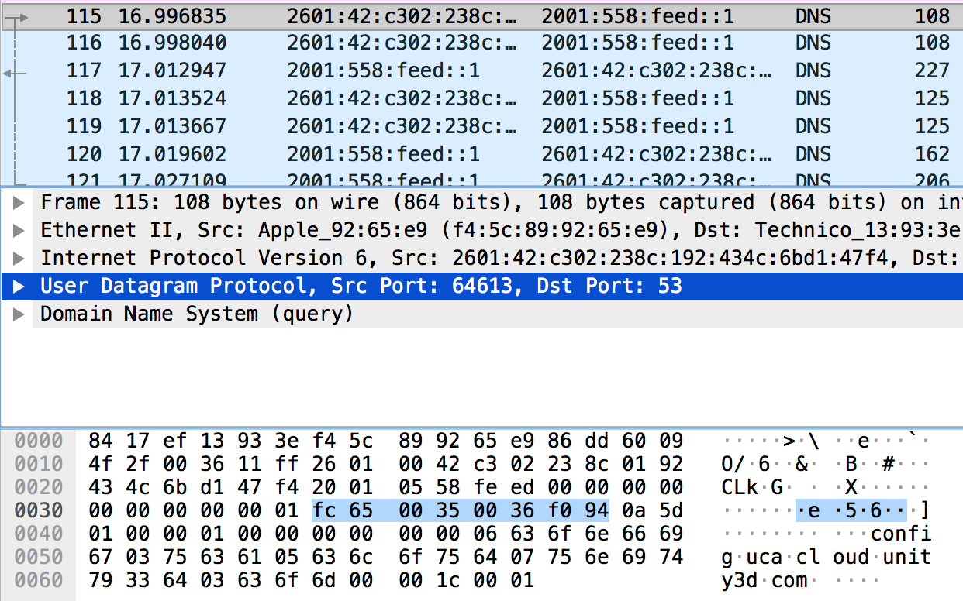

TCP Header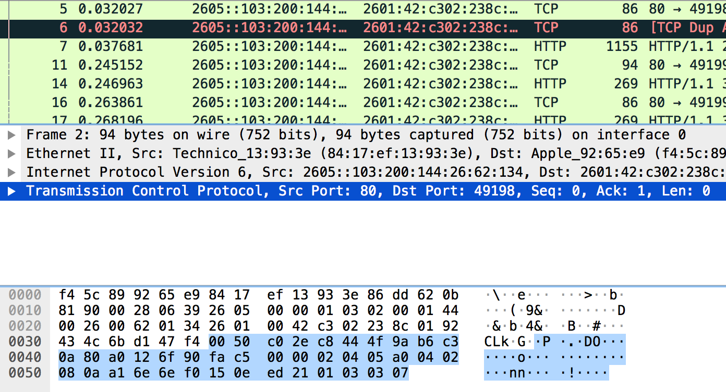

TCP 3 Way Handshaking packets



UDP Checksum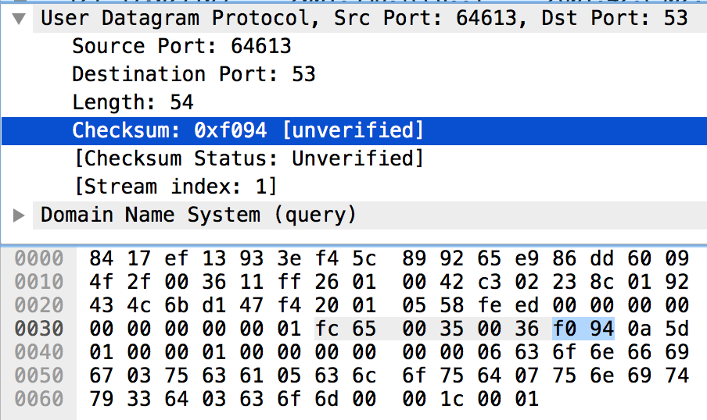

Hexadecimal to Decimal:

F094 = 61588

The results of (b) and (c) are the same